I. Background and Status
The Western Regional Air Partnership (WRAP) is a voluntary organization of western states, tribes, local air quality agencies, and federal agencies. The WRAP has been supporting the work of its members on regional haze since 1997. Historically, the WRAP work products are the result of direction and priorities from the Grand Canyon Visibility Transport Commission and the WRAP Board as carried out through Committees, Forums, and Workgroups addressing state, tribal, Federal Land Manager (FLM), Environmental Protection Agency (EPA), industry, and environmental groups’ collective needs and air management concerns for regional haze planning.
The WRAP is the successor to the Grand Canyon Visibility Transport Commission, which made recommendations in 1996 for improving visibility in the sixteen national parks and wilderness areas on the Colorado Plateau. The WRAP continues to promote, support and monitor the implementation of those recommendations throughout the West. With the promulgation of EPA’s regional haze rule in 1997, the WRAP was formed as the regional planning organization for the Class I areas in the fifteen western states with the goal to assist states and tribes in developing implementation plans to improve visibility in all Western Class I areas. A number of committees and forums were used to develop WRAP work products and provide for discussions among the various partners on specific regional haze and air quality related topics including: Stationary Sources, Mobile Sources, Fire Emissions, Dust Emissions, Emissions, Economics, Monitoring, Modeling, Planning, Communications, and Pollution Prevention.

The WRAP’s vision is to be the leading technical and planning information source for air quality management in the western United States. The Partnership continues to promote, support and monitor the implementation of regional haze plans to improve visibility in all Western Class I areas through a process that strives for consensus among its partners and stakeholders. Class I areas in the western states are national treasures constituting 75% of the nation’s Class I areas. The WRAP assists its membership to explore, understand, and address a variety of regional air quality issues including regional haze, climate change, ozone, particulate matter, and deposition of nitrogen and mercury.

This Work Plan is intended to describe planned WRAP efforts to develop and maintain critical sets of data and to further define and understand emissions from a number of source sectors relevant to western air quality, for the 2014-18 timeframe.

Accomplishments

From 1997 through today, the WRAP has been successful in developing policies and technical systems to address member’s needs. Many of these products remain applicable and useful to WRAP members today, selected examples include:

Air Pollution Prevention

Communications Manual

Economic Analysis Framework

Sources In and Near Class I areas
- Evaluation of PM₁₀ SIPs and Their Applicability to Visibility Control in Western Class I areas

Tribal Resources

Dust
- Final Feasibility Analysis of the Implementation of the WRAP's Dust Definition
- Fugitive Dust Handbook
- NM Dust SIP Pilot Study for the Salt Creek Wilderness Area

Fire
- Policy for Categorizing Fire Emissions
- Policy on Enhanced Smoke Management Programs for Visibility
- Policy on Annual Emissions Goals for Fire
- Policy on Fire Tracking Systems
- Fire Emission Tracking System

Oil & Gas Emissions
- Phase III 2006 Base Year Emission Inventory Project
- Phase IV 2009 Update Emission Inventory Project
- Piceance Pilot Project Oil & Gas Mobile Source Inventory
- Williston and Great Plains Basins’ Oil & Gas Emission Inventory Project
- Analysis of States’ & EPA Oil & Gas Air Emission Control Requirements for Selected Basins in the Western U.S.

Regional Haze Planning
- Reasonable Progress 4 Factor Evaluation Project
- §309 SO₂ Backstop Cap and Trade Program Materials
- Technical Support System for Regional Haze Planning
- WRAP BART Clearinghouse

WRAP Charter

Since its inception in 1997, the WRAP has updated its Charter on two occasions, once in 2009 and again in 2014. The organization is staffed and administratively supported by the Western State Air Resources Council (WESTAR) and is focused primarily on providing regional air quality technical support for a variety of regional air quality issues of interest to the membership. The WRAP membership has changed over time. The original WRAP Board was comprised of equal membership from state and tribes in partnership with federal agencies. Governors and tribal leaders or their designees were represented on the Board. The current WRAP is open to all states, federally recognized tribes, and local air agencies in the geographic region encompasses by the fifteen western states. Membership has expanded to include a diverse group of air quality management professionals from the 15 western states, 17 tribes, 26 local air agencies, 4 federal land management agencies, and the EPA. The Board is made up of 5 state, 5 tribal, 2 local air agency, and 5 federal agency representatives. A more detailed description of the current WRAP organization and structure is included in Section II of this work plan.

The 2014 WRAP Charter lays out the purposes of the organization, which demonstrate a continuing need for regional air quality efforts in support of the membership:

- Maintain and update the regional haze work that WRAP has developed and continue to make the data and tools available for states and tribes to use as they implement their regional haze implementation plans;
- Develop a common understanding of current and evolving regional air quality issues in the West, such as regional haze, ozone, fine and coarse particulate matter, nitrogen deposition and critical loads, and mercury and other hazardous air pollutants;
- Examine and discuss Western regional air quality issues from a multi-pollutant perspective;
- Develop and maintain regional databases that support regional and sub-regional technical analyses. This includes collection and analysis of data from various sources to produce regionally consistent, comparable, complete, and transparent results, able to be utilized and relied upon by individual jurisdictions and agencies;
- Collaborate with USEPA to ensure that, to the maximum extent possible, WRAP data and analyses are compatible with and leverage work conducted at the national level. This could include WRAP work to compile data and analyses related to international, off-shore, and other sources of air pollution affecting Western air quality;
- Evaluate the air quality impacts associated with regionally significant emission sources, such as mobile sources, fire, traditional and alternative energy development/extraction, windblown dust, and electricity generation, and, as warranted, to discuss regional and cross-jurisdictional strategies to improve air quality and mitigate the impacts from such sources;
- Consult with air quality agencies in other regions to reduce duplication of effort and enhance efficiency and consistency of databases and analyses;

- Evaluate how the impacts of climate change may affect air quality in the West; and
- As requested by the membership, formulate and advance consensus positions on Western regional air quality issues.

In order to address these important organizational objectives, the WRAP is continuing efforts to develop and maintain a regionally-consistent and comparable body of technical data and analyses for use in western air quality planning. New or updated technical work is needed as sources and data change over time and as new research emerges; the WRAP’s activities serve to improve the body of technical knowledge and information available for air quality management efforts. The sections of this Work Plan describe planned WRAP efforts to develop and maintain critical sets of data and to further define and understand emissions from a number of source sectors relevant to western air quality, for the 2014-18 timeframe.

Regional technical analysis and planning support work

Over time, the WRAP has developed a regionally-consistent and comparable body of technical data and analysis tools that are used in its ongoing work to address regional haze requirements and other regional air quality issues. The Regional Haze Rule has a nominal 60-year implementation period to reach natural visibility conditions, and requires tracking of visibility monitoring and emissions data, and ongoing analyses of source apportionment, projection of future visibility conditions, and verification/adjustment of reasonable progress goals to improving visibility for each Class I area. New or updated technical work is needed as emission sources and data changes (i.e., Oil & Gas development) and as new research emerges. Section III of this Work Plan describes activities that will serve to continue the WRAP’s legacy of assisting its members with regionally-consistent technical data and analyses for the 2018 Regional Haze Plans due from each of the 15 WRAP region States. This Work Plan also describes how leveraging, collaboration of WRAP member agencies’ technical capabilities, and funding resources will be applied assist with the regional data and transport analyses for the emerging regulatory activities related to revisions of the Ozone and Particulate Matter National Ambient Air Quality Standards (NAAQS), as well as the air quality impacts nitrogen and mercury deposition, even as sources and climate change. The WRAP will continue technical regional analyses for emissions, air quality, and meteorology and deliver those results in transparent, well-documented web databases.

This Work Plan identifies existing resources and funding to accomplish these activities; a preliminary integrated budget is shown in Appendix K, with summary budgets in each Technical Appendix. This Work Plan has organized and analyzed dependencies for WRAP activities – the Work Plan addresses what we know we have to do, at this point in time, which are Regional Haze planning support and regional technical analyses. Significant gaps in funding and/or functional technical collaboration are also identified – filling those gaps is a key outcome for a successful regional technical organization.

The Work Plan also discusses what is known about expected near-term changes to air regulations that could dramatically affect air quality planning in the West – making Ozone a broadly regional air management challenge. The Work plan offers more clarity about work needed in the first 2 years (2014-15) and is intended to provide a road map to an annual decision process for WRAP member agencies about what additional regional work to take on beginning in 2016. It is expected that this Work Plan will need an update(s) over the next few years.

Status of key Western Regional Emissions categories

- Mobile Sources – EPA standards for land-based engines and fuels will greatly reduce emissions from mobile sources. Mobile sources are the largest source of nitrogen oxide emissions in the West. These standards will reduce mobile source emissions of nitrogen oxides by 90% over the next 15 years, even as the West continues to grow.

- Oil & Natural Gas Production – Gas and more recently, Oil production, have expanded dramatically in the Intermountain West in the last decade. Gas production increased while prices have varied by a factor of more than 2. Existing production has been supplemented with new production. Associated emissions have increased and are projected to increase further.

Figure 1. Variation in production and price of Natural Gas in the Intermountain West. (source: Energy Information Administration).

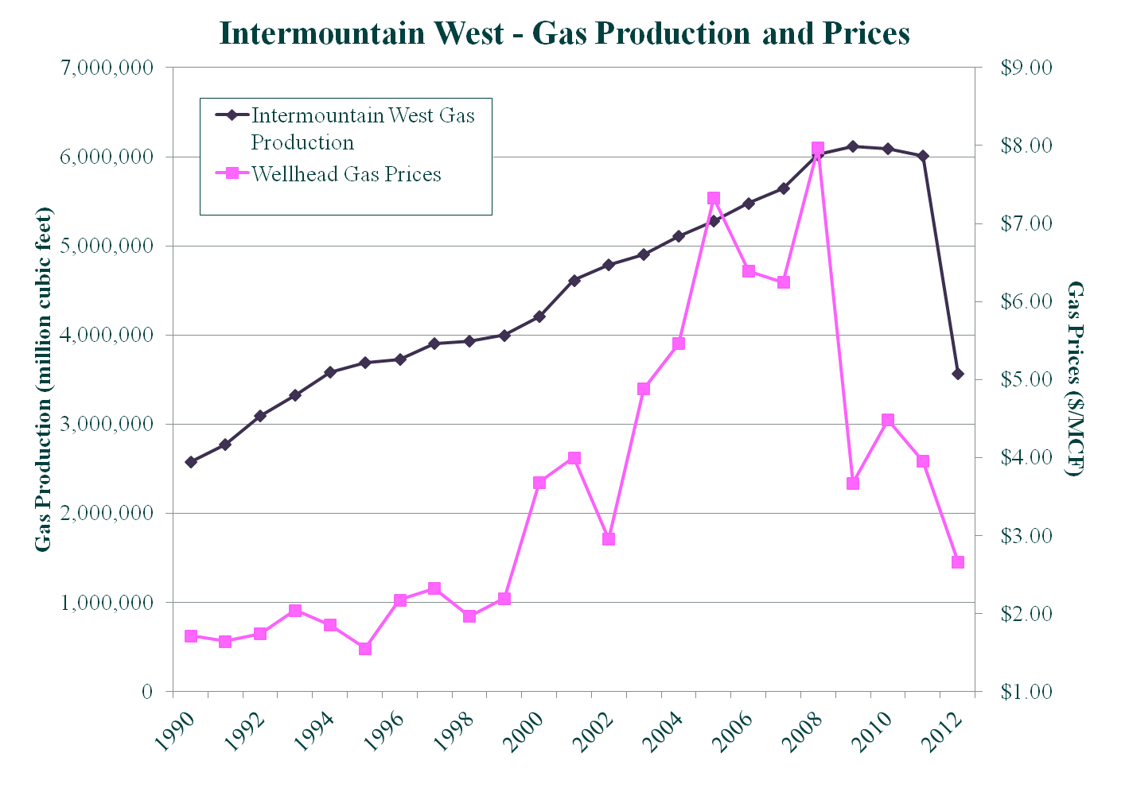

- Fossil Fuel Stationary Sources and Electrical Generating Units (EGUs) – By 2018, through Best Available Retrofit Technology (BART) implementation and the SO₂ Backstop Cap and Trade Program implemented by several western states under Clean Air Act §309, significant additional reductions of SO₂ and NO_{x} emissions are expected. These control programs in the western states’ existing baseline Regional Haze Plans will address the long-standing issue of emissions from grandfathered sources, especially from coal-fired EGUs.

Figure 2. WRAP region Power Plant Emissions Trends – Western Interconnect
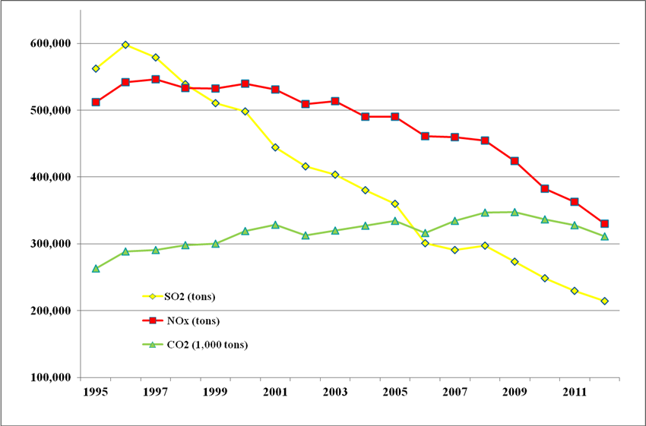
Data Source: EPA Clean Air Markets Division
- Prescribed Burning and Smoke Management – Western states/tribes/federal land managers have established smoke management programs to ensure that air quality impacts are minimized when prescribed burns are necessary on public and private land. In addition, the WRAP has implemented a fire tracking system to help land managers and air quality planners manage controllable smoke impacts on a regional basis. Natural, unplanned fire remains a very significant and highly variable source of air pollution in the western U.S. and additional studies and resources are need to understand the impacts of fire emissions on regional and local air quality management efforts.

Figure 3. WRAP region wildfire activity (acres – source: National Interagency Fire Center).
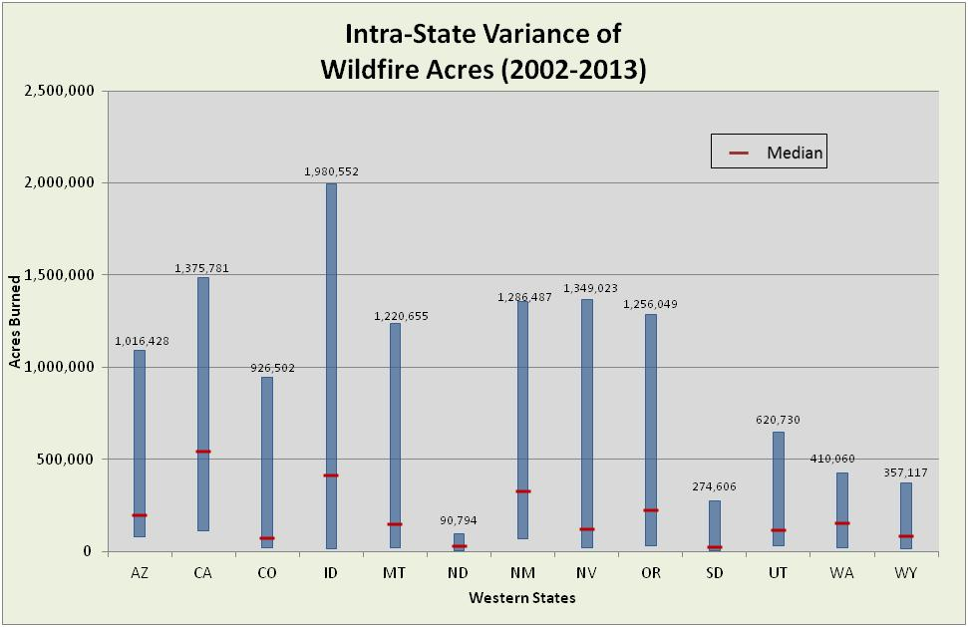

- Regional Haze planning presents a number of challenges to achieve continuing reasonable progress toward the Clean Air Act’s national visibility goal. Numerous analyses of source contributions and controls for anthropogenic sources will be required on a regional basis.

Figure 4. Conceptual trend for WRAP region emissions affecting Regional Haze planning.
